Speed up to slow down- a lens on return to sport protocols through ACL-R
Social media has idolized and created a fandom where exercises for ACL-R have become more captivating. This might help some individuals return to sport by mimicking the motion or activity that they have to do in their sport. The question is, does it prepare athletes to be back on the field by doing it?
The tangible answer is “it depends.” In the return to sport process, there needs to be some considerations to be taken into account such as physical (quad/hamstring strength, rom, hop test, etc), psychological (ACL-RSI scale), sports specific (T-test, dynamic movements, return to sport continuum), and timed based consideration.^{1,2,3} All these factors should be interwoven into the decision-making process to set up the athlete/patient for success and minimize the risk of re-injury. So how can we improve?
As the title of this article suggests, the concept of nailing down the basics at a world-class level early on, will ultimately help clients accomplish all of their goals. The therapist should make it a priority to increase their range of motion, quad/lower extremity strengthening, and gait mechanics as soon as possible. Afterward, focusing on slowing down the progression when the phase of plyometrics, return to sport, and competition starts is important.
In this day and age, everybody wants things to be done right away, yet data from years of ACL reconstructions shows that rushing through the progress is failing our society. Beischer S. Et Al showed that the nine-month mark appears to be a good minimum for RTS. They showed that individuals who return to their sport before those nine months were 3-7 times more likely to sustain a new ACL tear.⁴ Unfortunately, clinicians take into account this nine-month mark as a prime period to return to sport, but it's not the time frame that concludes the result, it's the work that's put in.
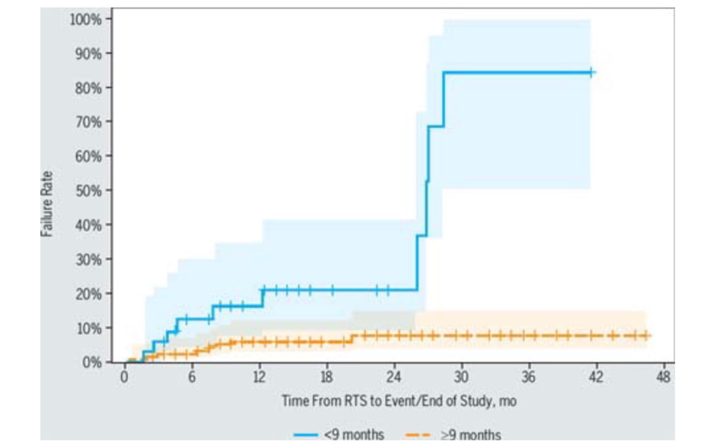
Beischer S et al. 2020 illustrating re-injury rates of athletes who return to sport prior to 9 months (blue) and after 9 months (orange)

Favorably, research has given us a glimpse of “goodness” over the years. Quadriceps femoris (QF) strength is an early marker for attaining the return to sport status. Early QF strength of 3 months showed improved knee function, knee confidence, knee performance, and knee mechanics during jogging.⁵ A solution to obtain this could be the implementation of personalized blood flow restriction training (BFR-RT). When this was compared to heavy load resistance training (HL-RT), it resulted in equal improvements in strength and superior improvements of self-reported function, y-balance performance, reduction in knee joint pain/swelling, and improvements in range of motion.⁶ Lastly, research has shown that there is a correlation between neuromuscular control with the drop vertical jump and the risk of a second ACL injury. Thus, video analysis of this movement should be implemented, as it has a high clinical utility that could identify a risk factor for future ACL re-injury.⁷
Realism has to come into the conversation, as well as factors such as insurance, influences, expectations, etc. They all play a role in the life of the athlete/patient which pushes the clinician to speed up the process. Paving the way and addressing concerns early on with the patient and family members should be pivotal in the plan of care. Communication between the clinician and their patient can be a difficult task, but they need to occur. It’s a marathon at the end of the day, not a sprint.
P.S. thank you to Jaime and Nicole

Works Cited
- Ardern CL et al. 2016 Consensus statement on return to sport from the First World Congress in Sport Physical Therapy. British Journal of Sports Medicine 2016; 50: 853-864
- Grindem H, Snyder-Mackler L, Moksnes H, Engebretsen L, & Arna Risberg M. Simple decision rules can reduce reinjury risk by 84% after ACL reconstruction: the Delaware-Oslo ACL cohort study. British Journal of Sports Med 2016; 50: 804-808.
- McPherson AL et al. Psychological Readiness to Return to Sport Is Associated With Second Anterior Cruciate Ligament Injuries. American Journal of Sports Medicine 2019; 47 (4): 857-862.
- Beischer S et al. Young Athletes Who Return to Sport Before 9 Months After Anterior Cruciate Ligament Reconstruction Have a Rate of New Injury 7 Times That of Those Who Delay Return. JOSPT 2020; 50 (2): 83-90.
- Kline PW, Johnson DL, Ireland ML, Noehren B. Clinical Predictors of Knee Mechanics at Return to Sport after ACL Reconstruction. Med Sci Sports Exerc. 2016;48(5):790-795.
- Hughes L, Rosenblatt B, Haddad F, et al. Comparing the Effectiveness of Blood Flow Restriction and Traditional Heavy Load Resistance Training in the Post-Surgery Rehabilitation of Anterior Cruciate Ligament Reconstruction Patients: A UK National Health Service Randomised Controlled Trial. Sports Med. 2019;49(11):1787-1805.
- Paterno MV, Schmitt LC, Ford KR, et al. Biomechanical measures during landing and postural stability predict second anterior cruciate ligament injury after anterior cruciate ligament reconstruction and return to sport. Am J Sports Med. 2010;38(10):1968-1978.

