Running Ground Reaction Forces & Step Rate Manipulation
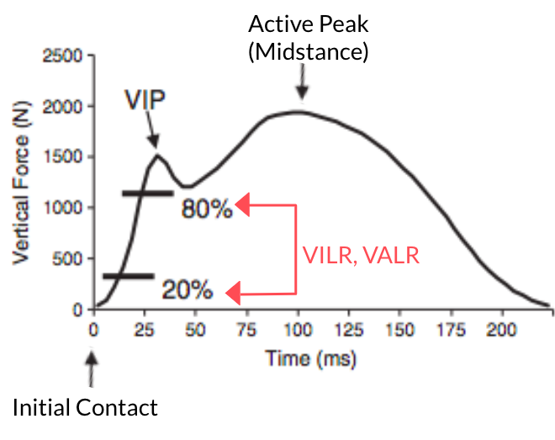
Figure 1. Vertical Ground Reaction Forces During Stance Phase ²

Running Ground Reaction Forces
During running, vertical ground reaction forces (GRF) reach a peak at mid-stance (occurring at the lowest point of the center of mass). As seen in the image presented, spikes at initial contact (IC) produce an initial vertical impact peak (VIP), which may slightly decrease before continuing on to produce an active peak (approximately 2.2 – 2.6 times body weight). Factors that can increase vertical impact peak (VIP) include rear foot strike patterns, downhill running, and decreased cadence. Influences that can decrease impact peak include midfoot/forefoot strike patterns, uphill running and increased cadence (which produces a muted or absent impact peak). While impact peak represents only eight percent of each stance phase in running, there is a continued debate whether this time frame provides enough contribution to the development of running injuries.³

Also seen in the image presented are Vertical Instantaneous Loading Rate (VILR) and Vertical Average Loading Rate (VALR). These represent the maximum slope (VILR) and the average slope (VALR) between 20-80% of the VIP. Increased VALR and VILR values have been associated with increased vertical body stiffness during landing. ¹

It has been reported that 21% of track and field athletes (in a one-year period) and 30-40% of military recruits during basic training sustain a stress fracture. Various studies have reported on the significance and potential implication of vertical ground reaction forces/loading rates in stress injuries. Specifically, showing that individuals with stress fractures demonstrate increased tibial shock, vertical loading rates and impact peaks compared to uninjured controls.⁶ Chan et al. and Willy et al support this implication. Both studies report an association between high loading rates of the vertical GRF and running injuries, including patellofemoral pain, tibial stress fractures and plantar fasciitis.^{1,8}

Step Rate Manipulation & GRFs
With this information, many studies have been performed in an effort to decrease ground reaction forces. In a study by Heiderscheit et al., step rate/cadence was increased (+10% of baseline, speed unchanged) to determine change in ground reaction forces. This study and a systematic review by Schubert et al. found that increasing step rate/cadence resulted in a statistically significant decrease in step length, vertical COM excursion, horizontal distance between COM and heel at IC, peak tibial acceleration and lastly peak ground reaction force. ^{5,7} A study by Edwards et al. similarly found that decreasing preferred step length (via increasing cadence/step rate) resulted in a decreased likelihood for tibial stress fractures by 3-6%. Specifically, finding that decreasing step length resulted in a decrease in the peak resultant tibial contact force.⁴

It is well known that overuse and running injuries require a multimodal approach of addressing strength, ROM, joint mobility, neuromuscular control, activity modification and functional gait retraining (based on impairments). As mentioned previously, current research suggests the association of impact forces and injuries in runners. It may be beneficial for clinicians to consider the role of step rate manipulation as an adjunct intervention to decrease ground reaction forces and potentially decrease the incidence of running related overuse injuries. One way for implementation would be to assess baseline cadence, calculate a +10% increase and use a metronome as external feedback (or music with tempo matching cadence) to establish a goal step rate.

- Chan, Z. Y., Zhang, J. H., Au, I. P., An, W. W., Shum, G. L., Ng, G. Y., & Cheung, R. T. (2018). Gait retraining for the reduction of injury occurrence in novice distance runners: 1-year follow-up of a randomized controlled trial. The American journal of sports medicine, 46(2), 388-395.
- Crowell, H. P., & Davis, I. S. (2011). Gait retraining to reduce lower extremity loading in runners. Clinical biomechanics, 26(1), 78-83.
- Dicharry, J. (2010). Kinematics and kinetics of gait: from lab to clinic. Clinics in sports medicine, 29(3), 347-364.
- Edwards, W. B., Taylor, D., Rudolphi, T. J., Gillette, J. C., & Derrick, T. R. (2009). Effects of stride length and running mileage on a probabilistic stress fracture model. Medicine & Science in Sports & Exercise, 41(12), 2177-2184.
- Heiderscheit, B. C., Chumanov, E. S., Michalski, M. P., Wille, C. M., & Ryan, M. B. (2011). Effects of step rate manipulation on joint mechanics during running. Medicine and science in sports and exercise, 43(2), 296.
- Milner, C. E., Hamill, J., & Davis, I. S. (2010). Distinct hip and rearfoot kinematics in female runners with a history of tibial stress fracture. journal of orthopaedic & sports physical therapy, 40(2), 59-66.
- Schubert, A. G., Kempf, J., & Heiderscheit, B. C. (2014). Influence of stride frequency and length on running mechanics: a systematic review. Sports health, 6(3), 210-217.
- Willy, R. W., Buchenic, L., Rogacki, K., Ackerman, J., Schmidt, A., & Willson, J. D. (2016). In‐field gait retraining and mobile monitoring to address running biomechanics associated with tibial stress fracture. Scandinavian journal of medicine & science in sports, 26(2), 197-205.

