Too Aggressive vs. Too Conservative: Re-Examining the RCR Protocol
As clinical experts in movement, the age-old saying “move it or lose it” truly resonates amongst the physical therapy community. There has been a recent influx of research on the appropriateness of that statement, specifically in regards to postoperative RCR patients. Silveira et al¹ performed a systematic review based on early intervention in the postoperative RCR population to assess the efficacy of early active range of motion in comparison to delayed active range of motion on clinical outcomes, rotator cuff integrity and return-to-work. Collecting information from 9 databases from November 2017 to February 2020, comparative studies that evaluated the effect of early active shoulder movement versus delayed active shoulder movement following rotator cuff repair were analyzed. After inclusion criteria and exclusion criteria were accounted for, eight studies involving 756 participants (379 early active shoulder movement; 377 delayed active shoulder movement) were examined.¹ Prior to the work completed by Silveira et al¹, there was high certainty evidence favoring early active movement for forward flexion (6-weeks), abduction (6-weeks), and external rotation (6-weeks, 3-months, and 6-months) post-surgery. The systematic review concluded that individuals who performed early active shoulder movement s/p RCR had greater shoulder ROM gains at 6-weeks, 3-months, and 6-months, but worse shoulder specific QOL indicators such as the Western Ontario Rotator Cuff Index at 6-months. Both early shoulder AROM and delayed shoulder AROM groups exhibited no significant difference in clinical outcomes or RTC integrity.
Proceeding from the Silveira study, Edwards et al.² conducted a systematic review to evaluate what kind of early active range of motion rehabilitation protocols would be the most beneficial with the least detriment to healing tissue. The writers based their rehabilitation protocol off electromyography (EMG) findings to help identify exercises that meet a cut point of 15% maximal voluntary isometric contraction (MVIC) or less and are unlikely to result in excessive loading in the early postoperative stages.² The study used predefined selection criteria mean MVICs as follows: low (0%–15% MVIC), low to moderate (16%–20% MVIC), moderate (21%–40% MVIC), high (41%–60% MVIC), and very high (greater than 60% MVIC).² Exploring the exercise protocols from 2159 studies, 43 exercises in total spanning passive range of motion, active-assisted range of motion, and strengthening exercises were evaluated.² Out of 13 active-assisted exercises, 9 were identified as suitable (15% MVIC or less) to load the supraspinatus and 10 as suitable to load the infraspinatus early after surgery.² This systematic review provided meaningful objective findings on the MCIV of therex evidence-based recommendations that may be used in a graduated rehabilitation program for the rotator cuff, including passive and active-assisted exercises that are unlikely to result in structural, failure from early to later stages following surgery.²
Nevertheless, it is always best to use one’s own clinical judgment and to consider the individual patients’ characteristics and risk factors that may negatively influence tendon healing and subsequently increase the risk for re-tear before prescribing postoperative exercise. The aforementioned studies from the Journal of Orthopedic & Sports Physical Therapy should be used as a pragmatic guide for the appropriate selection of exercises to prescribe to patients throughout the postoperative timeline after rotator cuff repair. Further research is needed to find a common ground between conservative rehabilitation protocols and rehabilitation protocols that are too aggressive, acknowledging that little is still known about the appropriate loading and exercise protocols post-op.
TABLE 1 Summary and Suggested Continuum of Rehabilitation Exercises, Based on Muscle Activation (Percent MVIC) for the Supraspinatus and Infraspinatus, for Both Early and Delayed Postoperative Motion Pathways
 | Time Point | Exercises
Phase 1: protection and early motion phase  EMG activation: ≤15% MVIC | Early: weeks 2–6  Delayed: weeks 5–8 | Passive ROM: flexion  Forward bow, supine therapist-assisted flexion, supine self-assisted flexion, sidelying flexion, towel slides, washcloth press-up  Passive ROM: rotation (no IR; ER to 30°)  Wall-assisted ER, supine bar-assisted ER, upright bar-assisted ER
Phase 2: active-assisted to active motion phase  EMG activation: ≤20% MVIC | Early: weeks 7–9  Delayed: weeks 9–12 | Active-assistive ROM: flexion  Ball roll, upright bar-assisted flexion, supported wall walk/slide (progression into unsupported), pulley-assisted flexion  Active ROM: flexion  Supine active press-up, reclined active press-up  Active-assistive ROM: rotation  Continue ER exercises as above. Commence self-assisted IR, bar-assisted IR
Phase 3: strengthening phase  EMG activation: 21%–50% MVIC | Early: week 10  Delayed: week 13 | Active ROM: flexion  Progress to standing press-up/active flexion (short lever, progressing to long lever), resisted active flexion  Active ROM—strengthening: rotation  Progress from seated to standing (in slight abduction to 45° of abduction) to sidelying (with and/or without pillow)  Seated row exercises, progressing to standing row/pulls: forward/scapular punches
Phase 4: late strengthening phase  EMG activation: ≥50% MVIC | Early: week 20  Delayed: week 20 | Active flexion/abduction  Prone horizontal abduction at 90° and 100°  Strengthening: rotation  Standing ER (in 90° of abduction) to prone (ER) in 90° of abduction  Push-up/push-up plus, dynamic hugs
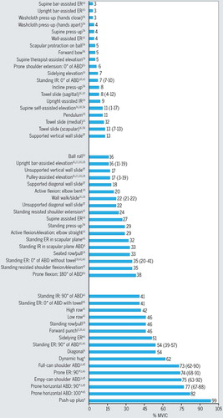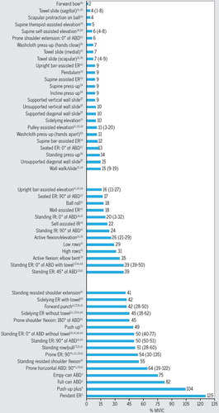
FIGURE 1. Supraspinatus pooled means (range) of percent MVIC ranking of exercises.
FIGURE 2. Infraspinatus pooled means (range) of percent MVIC ranking of exercises.
©2021 Journal of Orthopaedic & Sports Physical Therapy d/b/a Movement Science MediaPowered by Atypon® Literatum

References
1. Silveira A, Luk J, Tan M, et al. Move It or Lose It? The Effect of Early Active Movement on Clinical Outcomes Following Rotator Cuff Repair: A Systematic Review With Meta-Analysis [published online ahead of print, 2021 May 15]. J Orthop Sports Phys Ther. 2021;1-65. doi:10.2519/jospt.2021.9634
2. Edwards PK, Ebert JR, Littlewood C, Ackland T, Wang A. A Systematic Review of Electromyography Studies in Normal Shoulders to Inform Postoperative Rehabilitation Following Rotator Cuff Repair. J Orthop Sports Phys Ther. 2017;47(12):931-944. doi:10.2519/jospt.2017.7271

