Clinician’s Corner
Nick Almonte PT, DPT, OCS

Headache? What’s The Confusion?

We have all heard a relative, spouse, friend, coworker or patient report that they have a headache at some point in our lives, with different circumstances and intensities surrounding each. You yourself have likely suffered from a headache and we have all heard that famous line, “I have a migraine today”. But are you or the person you are talking to or treating really suffering from a migraine? There are several types of headaches, each of which have different presentations and treatments. It’s important to know what type of headache your patient is reporting as that can guide your treatment and preface if physical therapy will be an effective avenue for relief.

Just how common are headaches? The World Health Organization reports that half to three quarters of adults ages 18-65 will have had a headache in the last year and among those 30% have reported a migraine. Migraines where found to be the sixth highest cause of work years lost due to disability world wide and headaches as a whole where found to be the third highest cause¹.

There are two main headache types: primary and secondary. Primary headaches include tension type headaches, migraines and cluster headaches. Secondary headaches include acute post traumatic headaches, chronic post traumatic headaches, headaches associated with disorders of the ears, eyes, sinuses, teeth or mouth and headaches related to psychiatric disorders^{2–4}. Cervicogenic headaches are a type of secondary headache that may be confused with tension type headaches or migraines⁵. With all of these types it is important to understand the manifestations and differences between them to better aide in both diagnosis and treatment.

Primary Headaches:

Tension type headaches are the most common type of primary headache (90% of adults). Women are more affected than men, with peak prevalence in 30-40 year olds. Higher education also increases the chances of developing a tension type headache and low blood levels of magnesium can lead to increased blood flow in the anterior middle and posterior cerebral arteries causing pain. Chronic tension type headaches can be linked to medication use and the muscles of mastication, sternocleidomastoid, and upper trapezius should be evaluated as they can be involved in symptom presentation. Treatment can include medication, manual therapy including soft tissue mobilization to the cervical spine musculature, contract relax stretching to the upper trapezius, levator scapulae, sternocleidomastoid, upper cervical spine mobilizations/distraction and headache SNAGS. Therapeutic exercise should focus on postural awareness and strength training of the cervical spine and shoulder girdles^{3,4,6}.

- Tension Type Presentation^{1–3}:
  - Dull pain, non-throbbing, tightness, or pressure around forehead or the back of head and neck.
  - Diffuse pain in tight headband pattern.
  - Pain bilateral, non-pulsating
  - Muscle aches and trouble focusing
  - Mild photophobia or phonophobia,
  - Attacks lasting 30 min - 7 days, Sleep disturbance is common
Migraines will affect 28 million people in the U.S. at some point in their lives (roughly 12% of the population). Six percent of men and eighteen percent of women will develop migraine headaches in their lifetime with the first attack usually developing before the age of 40. A migraine can also be present with or without an aura and treatment can include various medications such as antiepileptic medication, Botox, beta blockers, NSAID’s, and herbal supplements^{2,3}. Acupuncture, cognitive behavioral therapy, and aerobic exercise have all been shown to decrease the frequency and severity of migraines. Certain food may also want to be avoided including milk, eggs, corn, and wheat, coffee, alcohol, and sugar as they can trigger an episode ^{1–4}.
- Presentation With Aura^{2,3}:
  - Unilateral
  - Starts with period of depression, irritability, and loss of appetite.
  - Paresthesia in the hands and face, may involve tongue.
  - If headache is preceded by visual symptoms, its known as visual aura: visual images change, loss of focus, spots of darkness, and zigzag flashing lights.
- Presentation Without Aura^{2–4}:
  - Dull or Throbbing
  - Usually build up gradually and may last for 4-72 hours
  - Headache is aggravated by physical activity, and associated with nausea
  - Combination of fatigue, difficulty concentration, neck stiffness, blurred vision, yawing, and pallor
  - Scalp may be tender
Cluster headaches are rare and usually the most painful type of the primary headaches. One to four percent of the population will have a cluster headache with men more affected than women and peak prevalence between 27 and 30 years old. There is a correlation between trauma and cluster headaches and attacks are common following afternoon naps and sleeping during the night. Sudden onset severe unilateral orbital pain will be present along with possible forehead sweating. Treatment is similar to that of migraines ^{2,3,5,6}
- Cluster Type Presentation²:
  - Severe unilateral orbital pain
  - Occurs in cyclical pattern- 15 min -2 hours
  - More common in men
  - Sudden onset of tearing
  - “Alarm clock headache” during morning sleep
Secondary Headaches:
Cervicogenic headaches are a secondary type of headache in which pain is referred from bony or soft tissue structures in the neck. It can be present with or without trauma and in pain treatment clinics can have a prevalence as high as 20% of the patients with chronic headaches. The mean age of patients with cervicogenic headaches is 42.9 years and they are four times more likely to occur in women⁵. Treatment of these headaches is multimodal and is similar to that of tension type headaches. Manual therapy should include active mobility exercises, cervical spine mobilization/manipulation with a possible focus on the upper cervical spine if acute/sub acute and the lower cervical spine/upper thoracic spine if chronic. These interventions should be combined with shoulder girdle strengthening, stretching to the cervical spine musculature and endurance exercises ^{4–6}
- Cervicogenic Presentation⁵:
  - Unilateral pain without side shift- can be bilateral at times
  - Pain in the occipital, frontal, temporal or orbital regions
  - Pain is generally deep and non throbbing- throbbing can happen when migraines are super imposed
  - Head pain in triggered by neck movements or awkward posturing
  - Pressure over the sub occipital region can elicit pain- as can valsalva coughing or sneezing
  - May have limited upper cervical segmental mobility, decreased or positive flexion rotation testing and diminished cervical spine range of motion.
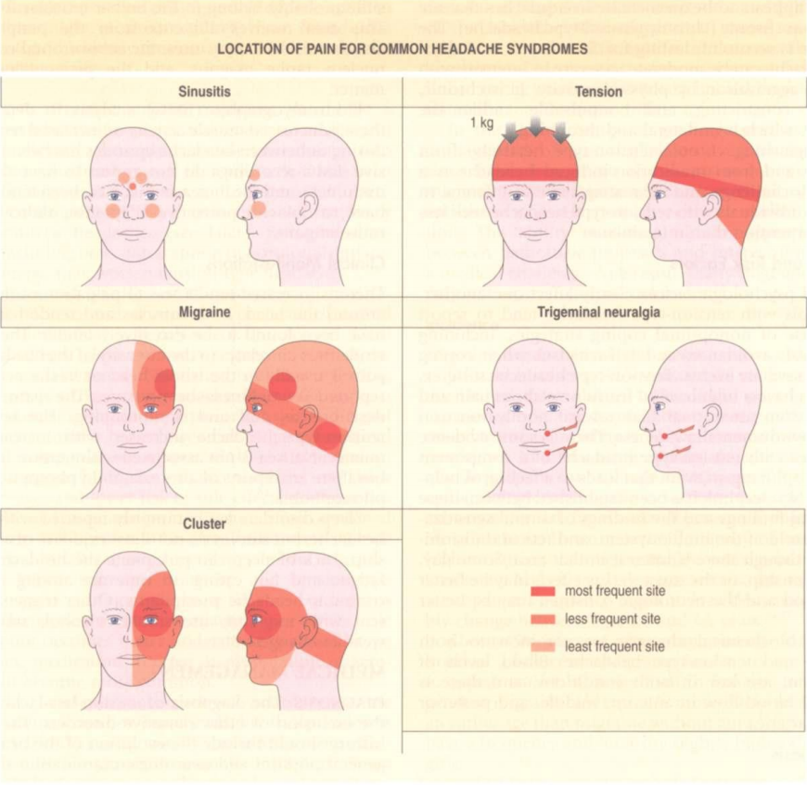
In outpatient physical therapy practice it is possible we will see all of these types of headaches, with tension type and cervicogenic being the most commonly treated directly. There are many ways to manage the varying types of headaches but understanding their presentation can lead to a more effective diagnosis and treatment plan.

Pathology: Implications for the Physical Therapist, 3e 3rd. 27751st edition. Saunders; 1994.

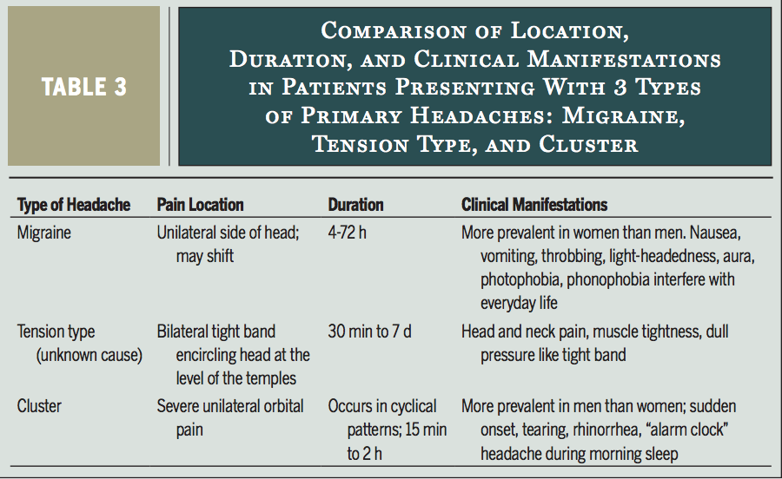
Pathology: Implications for the Physical Therapist, 3e 3rd. 27751st edition. Saunders; 1994.

References:
1. Headache disorders. https://www.who.int/news-room/fact-sheets/detail/headache-disorders. Accessed June 18, 2019.
2. Dutton M. Dutton’s Orthopaedic: Examination, Evaluation and Intervention, Fifth Edition. 5 edition. S.l.: McGraw-Hill Education / Medical; 2019.
3. aa. Pathology: Implications for the Physical Therapist, 3e 3rd. 27751st edition. Saunders; 1994.
4. Blanpied PR, Gross AR, Elliott JM, et al. Neck Pain: Revision 2017. J Orthop Sports Phys Ther. 2017;47(7):A1-A83. doi:10.2519/jospt.2017.0302
5. Biondi DM. Cervicogenic Headache: A Review of Diagnostic and Treatment Strategies. J Am Osteopath Assoc. 2005;105(4_suppl):16S-22S.
6. Mesa-Jiménez JA, Lozano-López C, Angulo-Díaz-Parreño S, Rodríguez-Fernández ÁL, De-la-Hoz-Aizpurua JL, Fernández-de-Las-Peñas C. Multimodal manual therapy vs. pharmacological care for management of tension type headache: A meta-analysis of randomized trials. Cephalalgia. 2015;35(14):1323-1332. doi:10.1177/0333102415576226

