Meniscus Allograft Transplantation

In an orthopedic clinical setting, we as clinicians commonly treat patients with meniscus pathologies including injury to or surgical history of meniscus tissue repair/removal. Often these symptomatic patients are of a younger age in which artificial joint replacement is not yet indicated or the loss of the peripheral meniscus is not yet severe enough despite the possible articular cartilage wear, knee instability, and progression of osteoarthritis. While our efforts can assist in reducing pain and preserving or repairing damaged meniscal tissue, there are cases in which the meniscus is not amendable to repair after injury. Although traditional repair of meniscus is seen to have fair to good results, the healing potential of meniscus tissue remains as a challenge secondary to its lack of vascularization in addition to its predisposition to secondary osteoarthritis.¹ Meniscus allograft transplantation (MAT) is becoming an increasingly utilized researched and practiced procedure for meniscus tissue injuries in hopes to improve clinical results. For appropriately indicated patients with symptomatic meniscal deficiency, MAT has demonstrated potential for a surgical solution to reduce pain, improve function, and limit degenerative changes.^{1,2}

However, MAT is a technically demanding procedure in which surgeon familiarity is critical in addition to appropriate candidate selection for successful outcome. Although research is continuing to evolve, the general indications for MAT found consistent through all studies include:
- Patients younger than 50 years old with a chief complaint of pain limiting their desired activities
- BMI < 35 kg/m2
- Previous meniscectomy (or non-viable meniscus state) with pain localized to the affected compartment
- Normal or correctable coronal and sagittal alignment
- Normal or correctable ligamentous stability
- No or minimal arthritis
- Willingness to comply with rehabilitation protocol
- Realistic post-surgical activity expectations^{1,2,3}

Meniscus allografts can be cryopreserved, fresh-frozen or deep frozen, fresh, or lyophilized or freeze-dried. Fresh frozen or deep frozen grafts, despite low cell viability, have been most commonly used because of lower disease transmission risks, maintenance of biomechanical properties, and overall relatively higher success rates. Appropriate graft sizing is crucial to promote tissue healing and restore the chondroprotective role of the meniscus. Lateral meniscus graft length is determined as 70% and medial meniscus graft length as 80% of the sagittal length of the tibial plateau.^{1,2} As far as surgical technique, there have been a variety reported although arthroscopic-assisted or all-arthroscopic have been most suggested. The specific technique utilized by surgeons is often dictated by laterality of injured tissue or need for concomitant procedures.^{2,3} Graft fixation techniques include either all-suture fixation or bone fixation. Bone fixation techniques are variable and include the use of bone plugs (more common for medial meniscus tears) or the use of a bone bridge (more common for lateral meniscus tears)². The difference in technique for lateral versus medial meniscus tears is associated with the need for proper placement of the anterior and posterior horn fixation sites while respecting the anatomical differences. At this time, surgical complications remain fairly low but can include mechanical failure, no change in symptoms, and graft extrusion.^{2,3,4}
In regards to rehabilitation post MAT, researched protocols and healing timelines are very similar to that of meniscus repair.^{5,6,7}
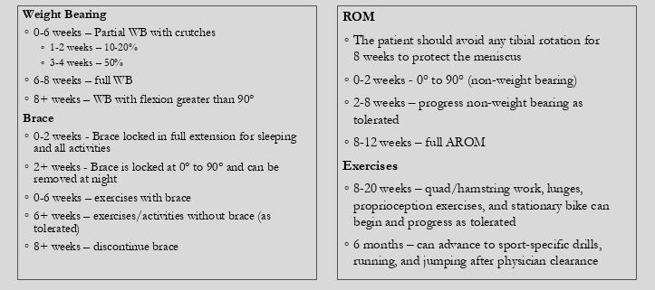

While outcome data remains relatively limited and inconclusive, some evidence suggests that MAT has been successful at reducing patient pain levels and providing short term functional benefit. Current research also suggests MAT to be chondroprotective with allografts having the potential to heal completely or partially to knee capsules close to one hundred percent when assisted arthroscopically.^{6,7} It has also been shown that lateral MATs have higher success rates and lower failure rates than medial MATs.³ However, short term follow up research suggests only about half of patients return to pre-injury level of play in addition to higher failure rates in ACL-deficient knees^{2,3}, which should be consistent with the athletic population considering such surgical procedure. Although research is promising and can be a great choice for our symptomatic patients, there is still much to consider regarding MAT including understanding the long-term outcomes of MAT and the ability of MAT to prevent or prolong knee arthroplasty.

- Lee SR, Kim JG, Nam SW. The Tips and Pitfalls of Meniscus Allograft Transplantation. Knee Surgery & Related Research. 2012;24(3):137-145. doi:10.5792/ksrr.2012.24.3.137.
- Frank RM, Cole BJ. Meniscus transplantation. Current Reviews in Musculoskeletal Medicine. 2015;8(4):443-450. doi:10.1007/s12178-015-9309-4.
- Searle H, Asopa V, Coleman S, Mcdermott I. The results of meniscal allograft transplantation surgery: what is success? BMC Musculoskeletal Disorders. 2020;21(1). doi:10.1186/s12891-020-3165-0.
- Figueroa F, Figueroa D, Calvo R, Vaisman A, Espregueira-Mendes J. Meniscus allograft transplantation: indications, techniques and outcomes. EFORT Open Rev. 2019;4(4):115-120. doi:10.1302/2058-5241.4.180052
- Southworth TM, Naveen NB, Tauro TM, Chahla J, Cole BJ. Meniscal Allograft Transplants. Clin Sports Med. 2020;39(1):93-123. doi:10.1016/j.csm.2019.08.013
- Noyes FR, Heckmann TP, Barber-Westin SD. Meniscus Repair and Transplantation: A Comprehensive Update. J Orthop Sports Phys Ther. 2012;42(3):274-290. doi:10.2519/jospt.2012.3588
- Young J, Tudor F, Mahmoud A, Myers P. Meniscal transplantation: procedures, outcomes, and rehabilitation. Orthopedic Research and Reviews. doi:10.2147/ORR.S94378

