Clinical Assessment Tool - Dynamic Leap and Balance Test
The Star Excursion Balance Test (SEBT) and Y-Balance Tests are two of the most-commonly used clinical assessment tools to measure dynamic stability following an ankle sprain or other lower extremity injury. The Dynamic Leap and Balance Test (DLBT) is a newer clinical assessment tool that can help us do the same. The DLBT requires a movement of body segments with a change in base of support where the SEBT and Y-balance require movement of body segments over a stable base of support. This small change can provide the clinician with useful information regarding the patient’s ability to re-establish dynamic stability on alternating legs.

SEBT and Y-balance
The Star Excursion Balance Test is a series of single-limb squats using the non-stance limb to reach maximally along eight designated lines. Following completion of the assessment, the distances between the affected and unaffected sides are compared or the distances before and after interventions are compared.
The Y-balance test is a modified version of the SEBT with maximal reach distances anterior, posteriolateral and posteriomedial. These tests are good for athletes who participate in ballet, gymnastics and/or ice skating, but may not be the best tool for athletes who are involved with sports that require cutting and quick changes in direction.¹
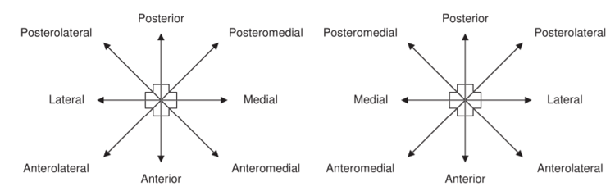
Figure 1. Reaching directions for the Star Excursion Balance Test¹

DLBT
Dynamic Leap and Balance test is a series of 20 hops (5 directions, 2 distances in each direction performed on both legs). The recommended distances are based on the anterior reach distance on the SEBT. The “short” distance is 100% of the anterior reach distance and the “long” distance is 150% of the anterior reach to encourage the participant to leap. The short distances need to be completed prior to the long distance and the participant starts anteriorly and moves clockwise.
The participant may complete three practice trials before completing their three timed trials. The score is the average time of the three trials. The trials are incomplete if the participant (1) touches down with the opposite foot, (2) demonstrates excessive hip abduction, (3) is out of testing position for >2 seconds and/or (4) steps, tumbles or falls.²
The DLBT mimics movement patterns involved in walking, running and cutting and is a great clinical assessment tool for all athletes.

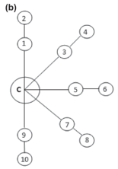
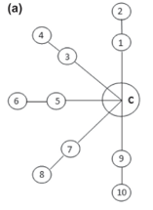

Figure 2. (a) DLBT pattern for right dominant limb (b) DLBT for left dominant limb
(1) Anterior Short, (2) Anterior Long, (3) Anteromedial Short, (4) Anteromedial Long (5) Medial Short, (6) Medial Long, (7) Posteromedial Short, (8) Posteromedial Long, (9) Posterior Short, (10) Posterior Long²
Populations Appropriate for DLBT
The DLBT is a “newer” clinical assessment tool and current research is centered around patients with chronic ankle instability.³ Further research is needed to determine the use for additional populations however, it can be inferred populations appropriate for the SEBT would be appropriate for the DLBT. This clinical assessment tool may also be utilized to identify athletes at greater risk for lower extremity injury as well.
References
- Gribble, P. A., Hertel, J., Facsm, À., & Plisky, P. (2012). Using the Star Excursion Balance Test to Assess Dynamic Postural-Control Deficits and Outcomes in Lower Extremity Injury: A Literature and Systematic Review. 47(3), 339–357. https://doi.org/10.4085/1062-6050-47.3.08
- Jaffri, A. H., Newman, T. M., Smith, B. I., & Miller, S. J. (2017). Original Research the Dynamic Leap and Balance Test ( Dlbt ): 12(4), 512–519.
- Jaffri AH, Newman TM, Smith BI, Vairo GL, Denegar CR, Buckley WE, Miller SJ. Dynamic Leap and Balance Test: Ability to Discriminate Balance Deficits in Individuals With Chronic Ankle Instability. J Sport Rehabil. 2019 Jun 6:1-8. doi: 10.1123/jsr.2018-0380. Epub ahead of print. PMID: 30676223.

