Current Evidence on Imaging in Patients WITHOUT Back Pain

By: Tom Kassan, PT, DPT

It is estimated that low back pain will affect almost 66% of adults at some point throughout their lives.¹ Unfortunately, this often leads to costly imaging, injections, and surgeries. However, new research is emerging that puts into question the results of CT and MRI imaging as a diagnosis for low back pain, and should have a great impact on improving future care.

In 2014, Brinjikji et. al systematically reviewed the literature to determine the age-specific prevalence of MRI and CT imaging findings in asymptomatic individuals. The study focused on 6 findings often associated with degenerative disc disease: disk degeneration, disk signal loss, disk height loss, disk bulge, disk protrusion, annular fissures, facet degeneration, and spondylolisthesis.¹

The systematic review included 33 studies reporting imaging findings on 3,110 individuals. As shown in table 2 below, disc degeneration was identified in 52% of 30 year olds. This increased to 80% in 50 year olds and 93% in 70 year olds. Additionally, disc bulges were identified in 40% of 30 year olds, increasing to 60% by age 50 and 77% by age 70. Although the authors list several limitations of the study, they made sure to specifically exclude any and all studies that “did not explicitly state that patients were pain-free” to ensure the integrity of the results.¹

The biggest question I have after reading this study, is that if a large majority of patients without pain have these findings on imaging, how clinically relevant are the imaging findings of patients that do have pain? And how should we explain this to our patients? There are several other studies that attempt to find the correlation between pain and imaging, but there has not been anything conclusive. For example, in 2016 Burgstaller et. al found that there was no correlation between MRI findings of lumbar stenosis and severity of pain.² Additionally, a literature review in 2014 concluded that “a reliable diagnostic tool that could help a clinician to determine if a disc is the source of the pain in patients with chronic LBP is still not available” after looking at several variations of MRIs and provocative discography.³ In another example, a cross-sectional study in 2013 found “… MRI findings were not related to the degree of disability or the intensity of LBP.”⁴ Lastly, a systematic review from 2011 found that “MRI findings of disc protrusion, nerve root displacement or compression, disc degeneration, and high intensity zone are all associated with LBP, but individually, none of these abnormalities provides a strong indication that LBP is attributable to underlying pathology.”⁵

I believe the overall consensus from these studies are of great value to clinicians and patients alike, and should help put the results of imaging in their place as only a (small) part of the patient examination. So while imaging can be important for ruling out more serious pathologies such as tumors, myelopathies, and fractures, it should not be used as a diagnostic tool for pain.

Additionally, these conclusions strengthen the role of physical therapists in performing a thorough subjective history and physical examination, by providing the most clinically relevant findings in properly treating a patient. The results of imaging should only be considered relevant when correlated to our clinical findings, not vice versa. Please use this table in your clinic to help in educating your patients and continuing to provide excellent care.

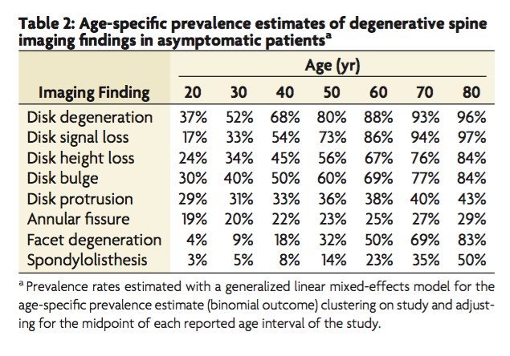

1. Brinjikji, W., Luetmer, P. H., Comstock, B., Bresnahan, B. W., Chen, L. E., Deyo, R. A., ... & Wald, J. T. (2014). Systematic literature review of imaging features of spinal degeneration in asymptomatic populations. American Journal of Neuroradiology.

2. Burgstaller, J. M., Schüffler, P. J., Buhmann, J. M., Andreisek, G., Winklhofer, S., Del Grande, F., ... & Held, U. (2016). Is there an association between pain and magnetic resonance imaging parameters in patients with lumbar spinal stenosis?. Spine, 41(17), E1053-E1062.

3. Brayda-Bruno, M., Tibiletti, M., Ito, K., Fairbank, J., Galbusera, F., Zerbi, A., ... & Sivan, S. S. (2014). Advances in the diagnosis of degenerated lumbar discs and their possible clinical application. European Spine Journal, 23(3), 315-323.

4. Berg, L., Hellum, C., Gjertsen, Ø., Neckelmann, G., Johnsen, L. G., Storheim, K., ... & Norwegian Spine Study Group. (2013). Do more MRI findings imply worse disability or more intense low back pain? A cross-sectional study of candidates for lumbar disc prosthesis. Skeletal radiology, 42(11), 1593-1602.

5. Endean, A., Palmer, K. T., & Coggon, D. (2011). Potential of MRI findings to refine case definition for mechanical low back pain in epidemiological studies: a systematic review. Spine, 36(2), 160.

