Blood flow Restriction Therapy for Lower Extremity Gains in the Clinical Population
Conner Gavin PT, DPT

Blood flow restriction therapy (BFR), has been a hot topic in recent years due to its claims to help make strength gains in a shorter amount of time with less load and resistance, making it very popular in the fitness community. Originally discovered in the 1960s in Japan it was not implemented in the United States for sports and therapy use until the early 2000’s. In research terms this makes this topic rather new since it often takes a couple years for a new intervention to gain some steam and merit in the clinical world. The building evidence over the years has shown some alarming results that can be very beneficial for clinical populations. Standard recommendations to build strength through resistance exercise requires an intensity of 60–80% of an individual’s 1-repetition maximum strength. Unfortunately, this can be very difficult to achieve with clinical populations (e.g post-op precautions, weight bearing restrictions, gait and balance abnormalities, generalized weakness) forcing low load resistance training to be used, which is less effective in building muscle and improving strength.

How exactly Does it work?
By applying a tourniquet to the proximal segment of a limb, mechanical compression can be applied that partially restricts arterial blood flow to structures distal to the cuff and impedes venous return. This results in inadequate oxygen supply to the muscles from restricted arterial flow and blood pooling in capillaries due to restricted venous flow. Muscle contractions when compressed then further impedes blood flow. This restriction in oxygen leads our brain to increase release of hormones. Increased release of growth hormone helps muscle cell regeneration, muscle cell reproduction and lipolysis, and insulin-like growth factor(IGF-1) which is important for muscle and bone growth and hypertrophy.

Formulas and Parameters
There have been many proposed calculations for use of % occlusion and how to calculate it. Overall, There should be 40-80% total occlusion to gain maximum benefits from BFR training. To calculate this a useful formula that is easy to do in clinic is:

Total Occlusion= .912(SBP) + .734(DBP) + 5.893(Thigh circumference in cm) -220.046

This formula gives you total occlusion. From here you can calculate 40-80% of the total. It is recommended to start on the lower end of 40% and build up to 80% as tolerated. It is important to note that reperfusion is needed every 5-10 minutes. So in between switching exercises BFR cuffs should be deflated and reinflated to the desired pressure to prevent muscle damage and overfatigue. Recommendations for exercises and breakdown of sessions are listed below.

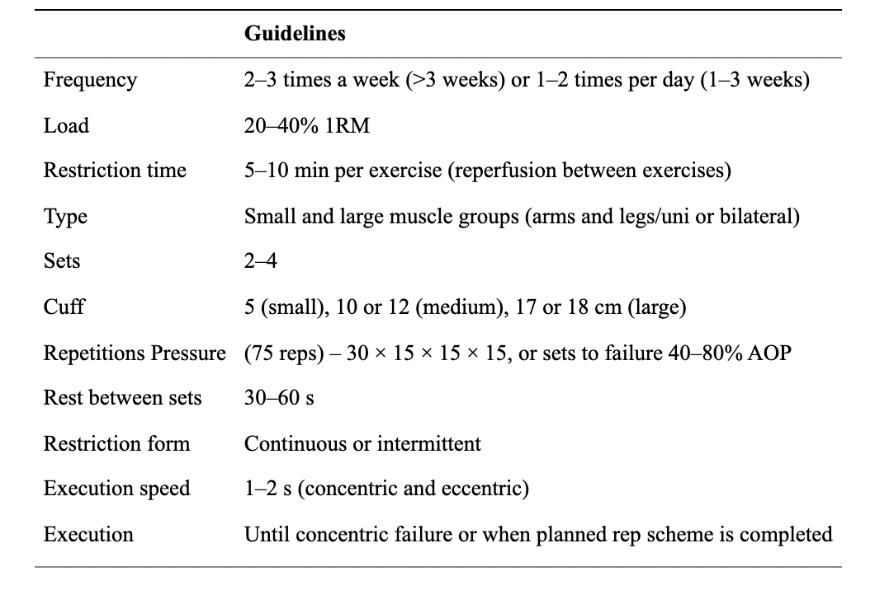

Is it safe?
- BFR may increase syncopal episodes in at risk populations
- BFR with resistance exercise may have greater effects of post exercises hypotension compared to regular resistance exercise.
- Be aware of patient populations at greater risk for venous thromboembolism (VTE)
  - major orthopedic surgery, major general surgery, lower extremity paralysis due to spinal cord injury, pelvic, hip, or long bone fractures, poly-trauma, prior DVT, pregnancy, genetic conditions that effect blood clotting and cancer
- Acute studies have not demonstrated a significant increase in blood coagulations via D-dimer and values, one of the most utilized clinical tests to rule out the presence of a DVT, after BFR
- It is important to check with you patient’s surgeon for post-op patients, or PCP to make sure the patient is a proper candidate. Post-op patients should be off all blood thinners and have LE circumferential limb measurements of relative equality to non-surgical side
- BFR should not be used in patients who; have severe uncontrolled hypertension, sickle cell anemia, limb infection, varicose veins, are pregnant, under the age of 12, any open soft tissue injury or skin graft, or tumors distal to the tourniquet

Recommended Use
When using BFR for post-op patients it is ok to follow recommended protocol exercises with ROM restrictions, open or closed chain restrictions, or weight bearing restrictions during use. Large compound movements incorporating as many muscle groups as possible in closed chain activity, performing various concentric, eccentric, and isometric movements, emphasizing proper form and movement patterns with adequate rest typically yields the greatest results.

References:
Patterson, Stephen D., et al. “Blood Flow Restriction Exercise: Considerations of Methodology, Application, and Safety.” Frontiers in Physiology, vol. 10, 2019, https://doi.org/10.3389/fphys.2019.00533.
Vanwye, William R, et al. “Blood Flow Restriction Training: Implementation into Clinical Practice.” International Journal of Exercise Science , vol. 10, no. 5, 1 Sept. 2017, pp. 649–654.

